Topic Evaluation

Preparation

Purpose
Students will use a heuristic to make decisions about which aspect of their primary interest topic holds the most value for their learning.

Specifically, this lesson requires students to:
- Develop a grid to assess the intersection between problems and questions
- Develop a decision grid to assess importance and relevance
- Consider the outcomes and potential consequences of decisions in advance of making the decision

Essential Question/s
How do decisions affect our actions?
How does decision making affect learning?

Materials
Pencil / Pen
Paper
Topic Evaluation Grid handout

Notes for Planning

Decision-making and focusing can be very challenging for students, particularly when they are at the beginning of a research process. Hopefully by now, students have a sense of the topic they are most interested in pursuing for their passion pursuit. Oftentimes, deciding what to actually pursue within a larger topic is where the real challenge begins. This lesson helps students look at the real problems in his or her field of interest and see where the problems of the field intersect with their own personal questions or specific areas of interest.

This is a complex and challenging task. Students may need more than one class period to complete this process, particularly if they have to go back to previous activities to make revisions. Revisions are welcome and should be encouraged! Students need to understand that processes associated with research, creativity, and productivity are not linear processes, so the more they choose to make changes to past work that enables them to progress in current work, the better.

The goal of this process is to help students start to identify a manageable pursuit. For example, if a student is interested in a designing an amphibious vehicle, they may believe that her final product will be a vehicle that she can climb into and drive into the water. In reality, she will need to start with multiple designs and build models to test her results. The final product will not be a full-scale vehicle. And, yeah, that really happened. I had a group of 8th grade boys who genuinely believed they would build a full-scale car/boat in the nine weeks we had available for the passion pursuit enrichment cluster… Instead, they built 1/4-inch scale model that effectively traveled from the beach into the San Francisco Bay (and back!).

Implementation

Time Needed
45 minutes

Notes for Instruction

Introduce the lesson as an opportunity to narrow the focus of their primary interest topic. You may want to start with a brief discussion (5-7 minutes; 7 minutes maximum) or begin with a brief journal writing exercise. Pose the question:

What are the factors that make a decision difficult?

Provide students with the Topic Evaluation Grid handout and make sure that they understand the directions. Be careful not to over-explain. It is important that students learn to read directions and understand expectations based on those directions, but be available for questions. A sample is provided to help scaffold understanding. You may want to use a document camera for the sample in order to save paper. Students do not need their own copy of the sample.

For this activity you will need your Unanswered Questions sheet and your Conflicts, Challenges, Problems, or Needs sheet from the Expanding Knowledge work.
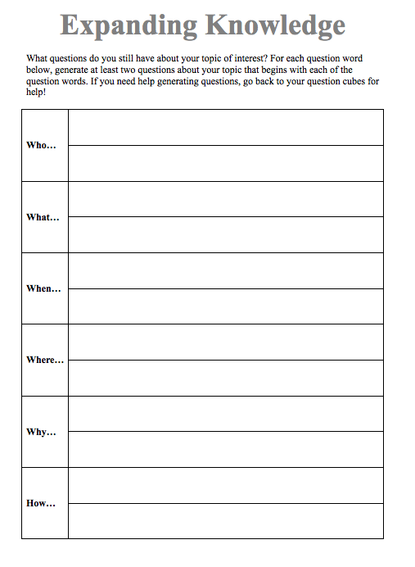
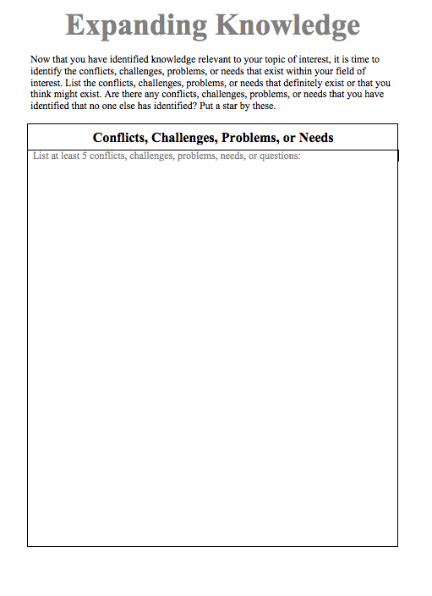

You should have at least 5 conflicts, challenges, problems, or needs (CCPN) and at least 12 unanswered questions (two each for who, what, when, where, why, and how).

In the grid provided below, list your CCPN items in the space provided along the top row and list your unanswered questions on the left side in the remain rows. A sample is provided for you.

Once you have transferred your unanswered questions and CCPNs to the grid, you should have a grid of empty boxes. Compare each CCPN with each unanswered question. For each pair determine if there is a similarity or relationship between the two items. For each pair that has a relationship (even if it is not an obvious relationship) or similarity, put an ‘X’ in the corresponding box (see the sample below).

For each of the ‘X’s you placed on the grid, evaluate the pair. Circle all of the ‘X’s that represent the most interesting topic, question, or idea to you.

 | CCPN | CCPN | CCPN | CCPN | CCPN
Who…
Who…
What…
What…
When…
When…
Where…
Where…
Why…
Why…
How…
How…

SAMPLE

Main Topic:  Sending humans to Mars | CCPN  Habitats for humans on Mars | CCPN  Growing food w/ limited sunlight | CCPN  Propulsion for exiting Earth’s orbit | CCPN  Comfortable space suits | CCPN  Challenges of space travel
Who… Who might be the first person to travel to Mars? | X | X |  | X | X
Who… Who will solve the engineering problems (fuel, water, radiation) presented by extensive travel in space? | X | X | X | X | X
What… What are the dangers associated with traveling to Mars? | X |  | X |  | X
What… What did scientists learn from the rovers that landed on Mars? | X | X |  |  | X
When… When is summer on Mars? | X | X
When… When did the idea of traveling to Mars first appear in literature?
Where… Where might humans land if they traveled to Mars? | X | X
Where… Where can humans live on Mars? | X
Why… Why might humans want to go to Mars? |  |  |  |  | X
Why… Why didn’t humans already land on Mars? |  |  | X |  | X
How… How will we ensure the safety of astronauts who travel to Mars? | X |  |  |  | X
How… How can SpaceX and Blue Origin compete with NASA? |  |  | X |  | X

