Topic Focusing

Preparation

Purpose
Students will use criteria to rank order specific sup-topics within their primary topic of interest to narrow the options for pursing an investigation.

Specifically, this lesson requires students to:
- Develop criteria for decision making
- Rank Synergy Items based on pre-specified criteria
- Consider the outcomes and potential consequences of decisions in advance of making the decision

Essential Question/s
How are criteria useful?
What are the steps in decision-making?
How do you make defensible decisions?

Materials
Pencil / Pen
Paper
Topic Focusing Grid handout

Notes for Planning

If students have never been introduced to the notion of evaluation criteria before, you will want to plan extra time for introducing this concept. However, the expectation is that students will understand the concept pretty quickly and be able to identify criteria like time, resources, support, value, interest, etc. as fundamental criteria for decision-making.

Once again, decision-making is a complex and challenging task. Students may need more than one class period to complete this process, particularly if they have to go back to previous activities to make revisions. Revisions are welcome and should be encouraged! Students need to understand that processes associated with research, creativity, and productivity are not linear processes, so the more they choose to make changes to past work that enables them to progress in current work, the better.

The goal of this process is to help students continue to focus on a topic that constitutes a manageable pursuit.

Implementation

Time Needed
45 minutes

Notes for Instruction

Part 1: Establishing Criteria
Open the lesson by introducing to students to the concept of “criteria”. You can accomplish this by asking “How would you define the word “criteria?” or “How do “criteria” help us make decisions?”. Whatever idea you like for introducing content will certainly work well.

Once students understand the concept of “criteria” put them in pairs or small groups to determine what criteria they would use to make a decision or choice. Explain to them that they are seeking the essential criteria. Allow students to work together to generate a list of 5-10 criteria for decision-making.

After students have developed general criteria, explain to students that they will be making a decision about which topic they to use for the passion pursuit project. Make sure they understand the number of weeks that they will need to stay focused on this topic as this may help them in the next step.

Ask students to individually develop a list of criteria that they could use to make a determination about which topic to select for their passion pursuit project.

Examples of criteria that students might consider:
- I can stay interested in the topic for an extended period of time.
- I will learn something important for pursuing this topic.
- I am most interested in this topic.
- Information about this topic is available to me.
- There is a problem I can solve or a question that I can answer.
- I know a lot about this topic already but I still have more to learn.
- There are other people I could work with on this topic who are equally interested.

This lesson may require two class periods depending on how thoroughly students considered the relationships and similarities between questions and field concerns in the Topic Evaluation Lesson.

Part 2: Narrowing the Focus

Students will need the Topic Focusing Grid for this portion of the assignment. Students should also have a list of criteria they could use to make a decision about their topic selection.

Using the completed Topic Evaluation Grid from Lesson 6.3a – Topic Evaluation, have each student specifically identify the similarities or relationships for each of the intersections on the Topic Evaluation Grid. Note: These will be the circled ‘X’s. They will be called “Synergy Items”.

Students should list these specific similarities or relationships in the first column of the Topic Focusing Grid handout. The similarities or relationships students have identified (Synergy Items) should constitute a list of very specific topics within the larger field of study and the more general topic that was likely identified in the earlier lessons (e.g. Interest Brackets, Webpage introduction, Journal entries, etc.). If students are not developing more narrowly defined topics and avenues for potential research or productivity with this process, make sure they understand the purpose for these processes before proceeding further.

Have students follow the directions on the Topic Focusing handout. Students should work to narrow their list of topics to three. If there are tied scores, have students first check their addition and then allow them to proceed with more than three topics or Synergy Items to the next lesson.

For this activity you will need your completed Topic Evaluation Grid from the last lesson.

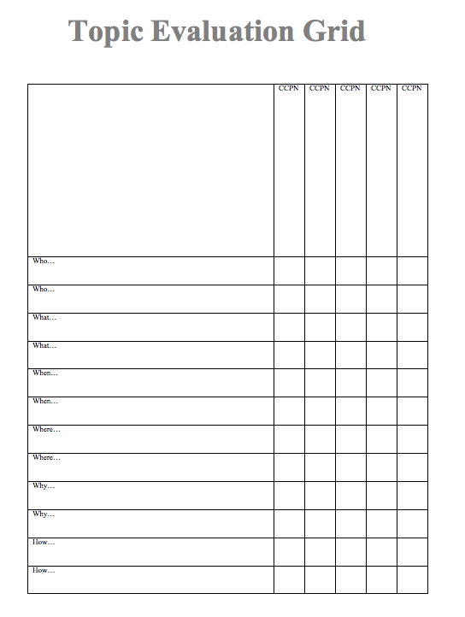

For each of the ‘X’s you placed on the grid and circled, specifically identify the relationship or similarity between each item in the pair. You might want to review the pairs and make sure that you circled the right ‘X’s. Remember: The circled ‘X’s represent the most interesting topic, question, or idea for you personally. Make a list of the most interesting similarities or relationships. We will call each of these a “Synergy Item”.

After you create your list, transfer the list to the Topic Focusing Grid. List your Synergy Items in the first column. It is okay if you do not have 11 Synergy Items, but you should have at least 5.

In the first row, list the Criteria you will use to narrow the focus of your topic.

Once you have the first column and the first row of the Topic Focusing Grid completed, you will give a score to each item on you list based on the criteria. The range of your score is 0-5. So, if the similarity or relationship you identified meets your criteria to an extreme then you would give it a ‘5’. If the similarity or relationship you identified does not meet the criteria at all, you would give it a ‘0’. So the range of your scores should be “Does not meet the criteria” to “Meets the criteria to the highest degree”. Add the scores for each row and place the total score for each row in the “Row Total” column.

Circle your top three scores. It is okay to have tied scores.

 | Criteria 1 | Criteria 2 | Criteria 3 | Criteria 4 | Criteria 5 | Row Total
Synergy Item 1
Synergy Item 2
Synergy Item 3
Synergy Item 4
Synergy Item 5
Synergy Item 5
Synergy Item 6
Synergy Item 7
Synergy Item 8
Synergy Item 9
Synergy Item 10
Synergy Item 11

