Lesson 4: Topic Selection

Preparation

Purpose
Students will assess the usefulness, viability, and relevance of their Synergy Items to make a final decision about which topic to pursue.

Specifically, this lesson requires students to:
- List the top ranked topics for exploration
- Specifically identify the question to answer or problem to be solved
- Identify the purpose or usefulness of pursuing solution to the problem or answer to the question
- Identify a potential audience that can evaluate a product in the domain
- Identify who might benefit from a solution or answer
- Identify potential outcomes

Essential Question/s
What makes a problem real?
Who benefits when problems are solved or questions are answered?
What is expertise?

Materials
Computer
Access to the Internet
Pencil / Pen
Paper
Topic Selection handout

Notes for Planning

This process should be fairly straight forward for students, however, they may have lost sight of the fact that they are supposed to be identifying a big question (i.e. one that cannot be answered with a Google search, one that will require an experiment or in-depth research) or solving a problem. This lesson has them re-focus on the goals of the passion pursuit and lays the foundation for the submission of a proposal.

The most important aspect of the work students will do in this lesson is to determine authentic audiences for their work. As a teacher, you recognize that it would be easier if you just gave them a rubric and identified the student’s classmates as the “authentic audience” but you know as well as anyone that the teacher and classmates do not constitute an authentic audience. Moreover, the quality of students’ work is exponentially increased when the audience has the knowledge and expertise to assess the quality of students’ work. Finally, given the amount of time that students will be and have already invested in this process, it is only fair that the work they do receive the level of evaluation that is commensurate with the effort.

If a student already has a high level of interest in a particular topic, they may already have mentors or more knowledgeable others who can help them continue to grow and develop in their field of interest. For other students, however, this may be the first time they have ever delved deeply into this specific topic or they may have reached a level of knowledge that requires more advanced expertise. To support students in finding experts in their field of interest, you can start by sending a survey home to parents within the school community. Ask questions like:
- What is your area of expertise?
- What do you do for work?
- What hobbies do you have?
- Would you be willing to serve in a mentor capacity for students in your class?
Typically adults are excited by the prospect of sharing their expertise and appreciate when students are pursuing knowledge in a related area.

The next level of searching for experts will be to contact a professor at your local or state university. This is a great way to introduce students to the idea that there is learning beyond the preK-12 setting. If there is no university nearby, consider contacting a teacher at the high school level who may have advanced knowledge in the area of students’ interest.

Don’t forget the power of the Internet! As the teacher, you should be the one to reach out to experts on the Internet on behalf of students. The Internet is powerful, but we still need to keep students safe. If an expert is only available via the Internet, we recommend that you become the liaison for student and oversee all communications that occur between the expert and the student.

Implementation

Time Needed
45 minutes

Notes for Instruction

Have students read the instructions for the topic selection handout. Once they have read and understand the instructions, have them complete the table. They should not have more than 5 Synergy Items, but there may be multiple problems or questions for any one of the Synergy Items. Students need to have a minimum of 3 Synergy Items identified. They will select one for their proposal and the remaining items will serve as contingency plans. See lesson 7.1 – Finalize the Plan for more details.

For this activity you will need your completed Topic Focusing Grid from the last lesson.

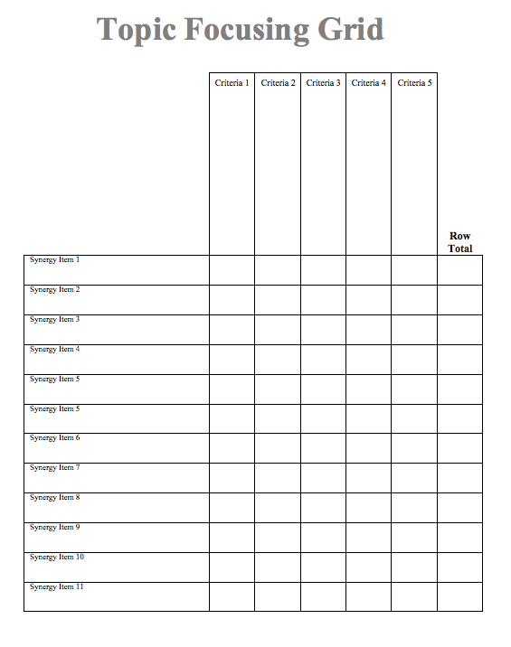

You should have your top three scores circled. If there is a tie, you may have more than three items but you should not exceed five items and you should not have all of your Synergy Items in the top.

For each of your top Synergy Items, you will be identifying the problem or questions, the purpose, the audience, the outcome, an expert evaluator. Each of these items is explained further below:
- Problem or Question: You may have lost track of the purpose of your passion pursuit as you went through the process of narrowing your topic. Here, you will once again identify a question that needs to be answered (remember, the answer cannot be found with a Google search) or a problem that needs to be solved for each of your top scoring Synergy Items.
- Purpose: This answers the question: “So what?” Why is your topic important to pursue? What value is there in solving the problem or answering the question?
- Audience: Who will benefit from the solution to your problem or the answer to your question?
- Outcome: What will be the product that results from your efforts? What format will you use to communicate a solution or answer to your audience?
- Expert: Who has the expertise or knowledge to support you as you pursue the answer to your question or solution to the problem? Who has the requisite knowledge to judge the quality of your outcomes? Keep in mind that this will likely not be your teacher or classmates. It will have to be someone outside the school.
Synergy Item: |  | Problem or Question:
Purpose | Audience | Outcome | Expert
Synergy Item: |  | Problem or Question:
Purpose | Audience | Outcome | Expert
Synergy Item: |  | Problem or Question:
Purpose | Audience | Outcome | Expert
Synergy Item: |  | Problem or Question:
Purpose | Audience | Outcome | Expert
Synergy Item: |  | Problem or Question:
Purpose | Audience | Outcome | Expert

